Editing Long Reactions in ISIS/Draw

Background

Chemists often work with long reactions, such as that shown below:

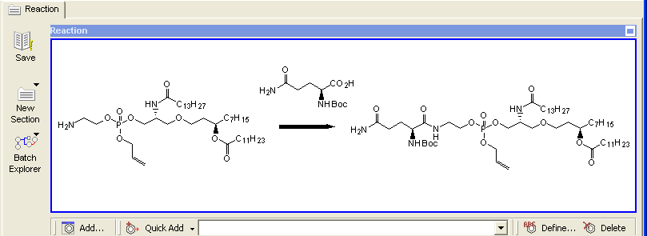

For editing in ISIS/Draw with standard ISIS/Draw settings, such as standard bond length = 1 cm., these reactions often do not fit across the ISIS/Draw editing page unless they are drawn on multiple lines, as shown below:

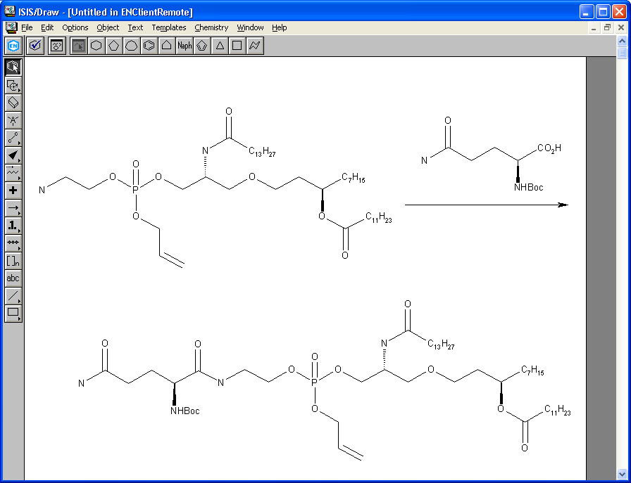

ChemDraw doesn’t recognize reactions that are drawn on more than one line like the above. This issue is being tracked as bug “Oss 29”, “CSBR-57318: Reactant/product structures not inline with arrow cause structures below arrow to be missing in tables”. The ChemDraw team is currently planning to address this in ChemDraw 11, which is not in the timeframe for this E-Notebook release, so this design is to add additional E-Notebook code to handle this issue, working around ChemDraw’s inability to recognize multiline reactions.

Because of the ChemDraw limitation, the design is to always store and render reactions on a single line in E-Notebook as shown in the first figure, but to edit them on multiple lines in ISIS/Draw.

When the user double-clicks to edit a reaction, code to “wrap molecules” will execute. This code functions much the same way word processors such as Microsoft Notepad and Word “wrap words”. This code will convert single line reactions to multiline reactions. We will call it the “wrapping code”.

When the user is finished editing and closes ISIS/Draw, “unwrapping code” will execute. This works similar to when one turns off the Word Wrap feature in Notepad, putting the reaction all on one line, and passing the reaction to ChemDraw as shown in the first figure.

A key requirement for the success of this design is that users will need to be trained to draw wrapped reactions in a certain way – such that concatenation of the lines in the unwrapping code will produce the correct chemistry. That is, in unwrapping, the last line will be concatenated onto the right hand end of the line above, and so on, until there is only one line. This is as shown in the figures above, and it is how all Word Wrap features of word processors function.

Note this is an initial design concept only. No prototype has been written until this design has been approved. Prototyping and testing will no doubt raise more detail issues that will need to be worked through.

Alternative design approaches

Zoom or reduce bond length

One approach that was considered was to zoom the drawing or reduce the bond length settings in ISIS/Draw. This was rejected by users, as it can reduce detail, such as the subscripts in Figure 2, to the point where they are no longer legible.

Use Landscape Mode

MDL technical support pointed out that it may be possible to write a PL program that will execute every time ISIS/Draw is launched, and set the printer settings to Landscape Mode, which would make the drawing area longer. This was rejected because it would do this even when users were using ISIS/Draw outside of E-Notebook, which would be undesirable.

Draw in grey area

Structures can be drawn in the grey area to the right of the normal white ISIS/Draw editing area. This was rejected because (1) it drastically compromises ease of use, and (2) it only helps for users with wide screens, and even those are not helped as much as is often necessary.

Change History
Date | Author | Comments
22-Aug-2005 | F. Putnam | Creation

